CWdgtDataTableEditSchema

Lines 1..6

CDlgDataTableEditSchema

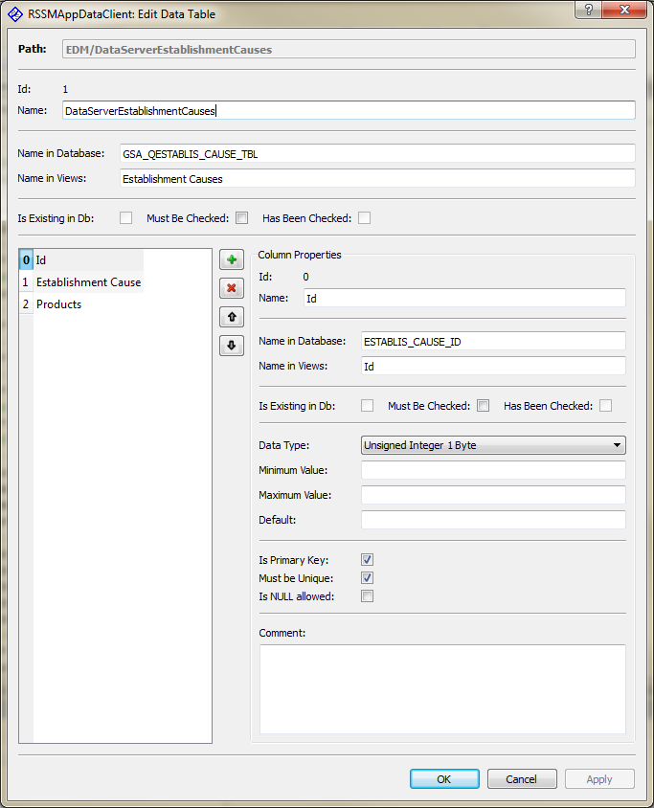

Splitter

WdgtDCs

CWdgtDataColumnEditSchema

TableView

CDataColumnsModel

The schema of a data table (table name, column collection, etc.) may be edited using class CWdgtDataTableEditSchema.

As the table to be edited may contain data (a collection of data rows) and also to allow canceling the changes only a copy of the table will be edited. On pressing the Ok or Apply button the changes will be transferred to the original data table.

Before changing the selected column the content of the edit controls of “CWdgtDataColumnEditSchema” will be saved in the corresponding data column instance.